**Project Report**

1. **INTRODUCTION**

**1.1** **Project Overview:**

The project aims to provide data-driven insights into Olympic sports participation and performance. By analyzing historical data, trends, and patterns, the project seeks to identify factors that influence athletes' participation in various Olympic sports. It will explore demographic information, such as gender, age, and nationality, to understand the representation and diversity within different sports. Additionally, the project will examine performance metrics, including records, rankings, and medal tallies, to uncover patterns of success and identify dominant countries or athletes. The insights generated from this analysis will contribute to a better understanding of the dynamics of Olympic sports and can inform strategies for promoting inclusivity and enhancing performance in future Olympic Games.

**1.2 Purpose:**

The purpose of the project is to utilize data analysis techniques to gain insights into Olympic sports participation and performance. By examining historical data and patterns, the project aims to achieve the following:

1. Understand the factors that influence athletes' participation in different Olympic sports.

2. Identify trends and patterns in demographic information to assess representation and diversity within various sports.

3. Analyze performance metrics to uncover patterns of success and identify dominant countries or athletes.

4. Explore the relationship between participation and performance in Olympic sports.

5. Inform strategies for promoting inclusivity and enhancing performance in future Olympic Games.

6. Provide evidence-based recommendations for optimizing sports programs and resource allocation.

7. Enhance understanding of the dynamics and evolution of Olympic sports.

8. Contribute to the overall knowledge and discourse surrounding sports participation and performance in the Olympic Games.

**2.** **IDEATION & PROPOSED SOLUTION**

**2.1 Problem Statement Definition**

|  |  |  |  |  |  |
| --- | --- | --- | --- | --- | --- |
| **Problem Statement (PS)** | **I am (Customer)** | **I’m trying to** | **But** | **Because** | **Which makes me feel** |
| PS-1 | I am a sports marketer | I'm trying to identify the most promising Olympic sports and athletes to invest in. | I'm facing challenges | Because in predicting the future success of different sports and athletes, making it difficult to make informed investment decisions. | I feel uncertain about which investments to pursue, and I worry that I may miss out on potentially lucrative opportunities. |
| PS-2 | As a coach of an Olympic sports team | I'm trying to optimize my training programs to improve the performance of my athletes. | I'm struggling | to identify the key factors that contribute Because to success in different sports, and I lack insight into the training methods and techniques that have been most effective for other athletes. | I feel frustrated and unsure about how to best support my team. |
| PS-3 | I am a sports journalist | I'm trying to write engaging stories about Olympic sports and athletes. | I'm facing difficulties in finding unique angles and interesting insights to highlight in my writing. | Because there is a lot of information available on the Olympic games, and it can be challenging to find new and compelling stories to tell. | I feel uninspired and struggling to produce high-quality content. |
| PS-4 | I am an Olympic athlete | I'm trying to improve my performance in my sport. | I'm facing challenges in identifying my strengths and weaknesses and understanding how to optimize my training regimen. | This is because there is a lot of information available on training for my sport, but it can be difficult to know what will work best for me. | I feel frustrated and unsure about how to best prepare for competition. |
| PS-5 | I am a fan of Olympic sports | I'm trying to gain a better understanding of the different sports and athletes competing in the games. | I'm facing challenges | Because in finding reliable and comprehensive information about the history, rules, and performance metrics of different sports. | I feel like I'm missing out on valuable insights and opportunities to appreciate the skills and talents of Olympic athletes. |
| PS-6 | As an event organizer | I'm trying to create an engaging and successful Olympic sports event for spectators. | I'm struggling | Because to understand what types of sports and activities will be most popular with my target audience, and which athletes are likely to generate the most excitement and attendance. | I feel uncertain about how to structure my event and worry that it may not meet the expectations of attendees. |
| PS-7 | I am a sports data analyst | I'm trying to develop accurate models for predicting the outcomes of Olympic sports events. | I'm facing challenges | Because in identifying the most relevant data sources and variables, and in developing models that account for the complexity and variability of different sports. | I feel frustrated and unsure about how to improve the accuracy of my predictions. |
| PS-8 | As a sports sponsor | I'm trying to identify the most effective ways to promote my brand in connection with Olympic sports events. | I'm struggling | Because to understand the preferences and behavior of my target audience, and to determine which types of promotional activities and partnerships are likely to generate the most ROI. | I feel uncertain about how to allocate my marketing budget effectively. |
| PS-9 | I am an Olympic sports coach | I'm trying to identify the most effective training techniques and strategies for my athletes. | I'm facing challenges | Because of challenges in staying up-to-date with the latest research and advancements in training science, and in tailoring my approach to the unique needs and strengths of each athlete. | I feel overwhelmed and unsure about how to optimize my coaching practices. |
| PS-10 | As an Olympic sports broadcaster | I'm trying to provide insightful and engaging commentary on live events. | I'm facing challenges | Because of challenges in staying up-to-date with the latest news and developments in each sport, and in providing meaningful analysis and context to viewers. | I feel pressured and stressed about my ability to provide high-quality commentary on a wide range of sports and events. |

**2.2 Empathy Map Canvas:**

EMPATHY MAP FOR DATA-DRIVEN INSIGHTS ON OLYMPIC SPORTS PARTICIPATION AND PERFORMANCE:

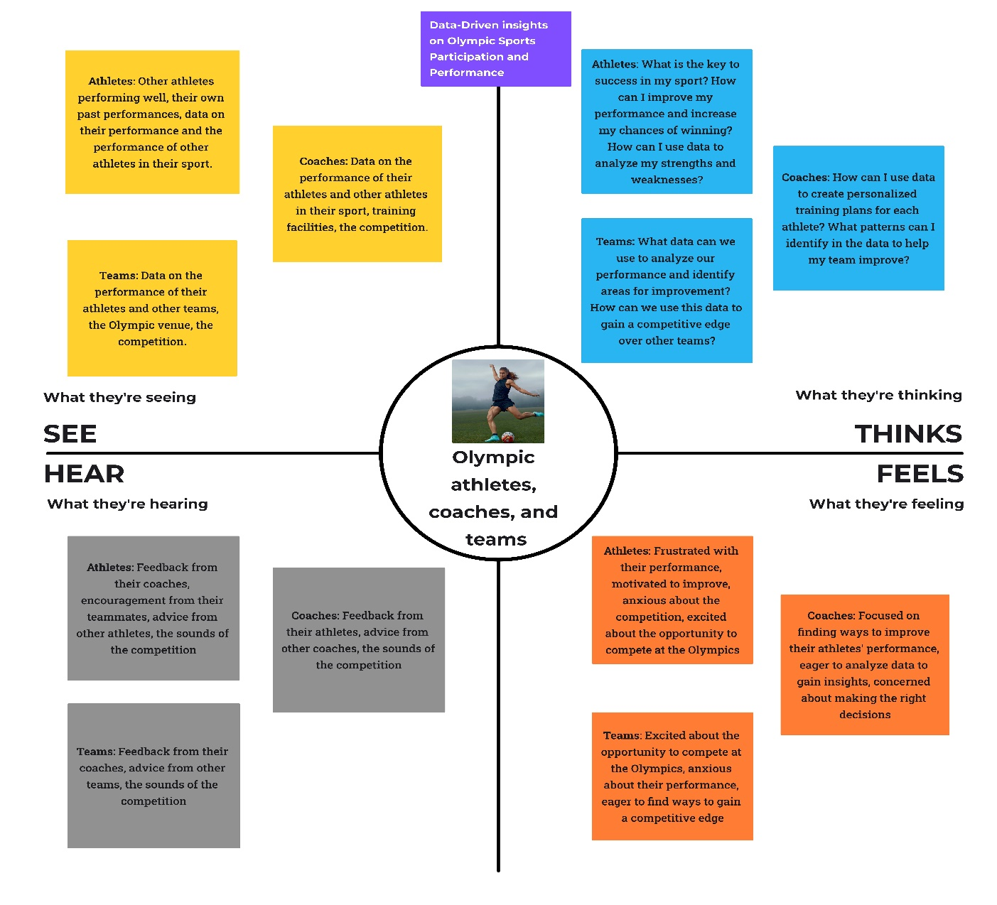

Reference: <https://www.mural.co/templates/empathy-map-canvas>

**2.3 Ideation & Brainstorming:**

Reference: <https://app.mural.co/invitation/mural/project6980/1683642594216?sender=udd997709f877f19413851184&key=73a110cf-cd3a-4876-a302-deb3aedde015>

**Step-1: Team Gathering, Collaboration and Select the Problem Statement**

**Step-2: Brainstorm, Idea Listing and Grouping**

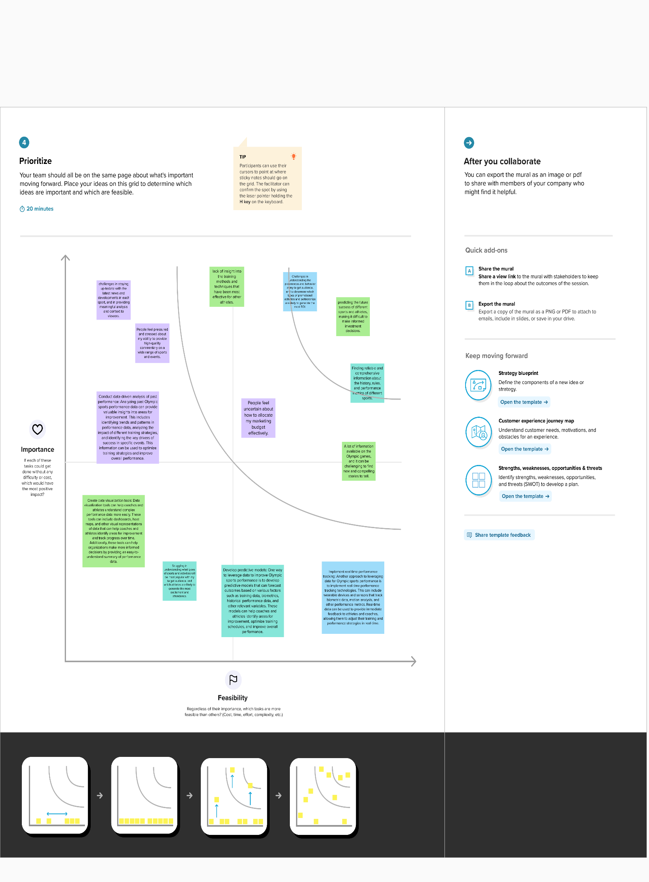**Step-3: Idea Prioritization**

**2.4 Proposed Solution:**

|  |  |  |
| --- | --- | --- |
| **S.No.** | **Parameter** | **Description** |
|  | Problem Statement (Problem to be solved) | Analyzing the vast amount of data available on Olympic sports can be challenging, and there is a need for data analytics techniques that can provide meaningful insights. Therefore, the problem to be solved is how to use data analytics to generate data-driven insights on Olympic sports participation and performance. |
|  | Idea / Solution description | The solution to generating data-driven insights on Olympic sports participation and performance involves a combination of data collection, cleaning, analysis, visualization, and interpretation. By using this approach, we can gain a better understanding of the complex factors that contribute to an athlete's success, which can help stakeholders make informed decisions that benefit the world of sports. |
|  | Novelty / Uniqueness | The novelty and uniqueness of generating data-driven insights on Olympic sports participation and performance lies in the comprehensive, interdisciplinary approach, real-time insights, and potential impact on policy decisions. This approach has the potential to revolutionize how we understand and analyze Olympic sports, leading to better performance and a more inclusive and diverse sports community. |
|  | Social Impact / Customer Satisfaction | Generating data-driven insights on Olympic sports participation and performance has the potential to have a significant social impact, including improved athlete performance, greater inclusivity and diversity in sports, and better resource allocation. It can also improve customer satisfaction among various stakeholders, including athletes, coaches, sports organizations, and fans. |
|  | Business Model (Revenue Model) | The revenue model for Data-Driven insights on Olympic Sports Participation and Performance could be a subscription-based service for sports organizations, coaches, and athletes. The service could offer different tiers of subscription packages with varying levels of access to data analytics and real-time insights. Additionally, the service could provide customized consulting services to help sports organizations and coaches optimize their training programs and improve athlete performance. The revenue model could also include partnerships with sports equipment and nutrition companies, where the insights generated from data analysis can inform product development. The revenue model could be further enhanced through the sale of data analytics tools and platforms to other industries beyond sports. |
|  | Scalability of the Solution | The solution for Data-Driven insights on Olympic Sports Participation and Performance is highly scalable due to the digital nature of the data and the ability to leverage cloud-based infrastructure. The solution can be easily scaled to analyze data from multiple Olympic games, different sports, and athlete profiles. The use of machine learning and artificial intelligence algorithms allows for automated data processing and analysis, reducing the need for manual intervention. Additionally, the solution can be integrated with other systems, such as wearable devices and social media platforms, to collect and analyze real-time data. As the solution is scalable, it can serve a broad range of customers, from individual athletes and coaches to large sports organizations and governing bodies. |

3. **REQUIREMENT ANALYSIS**

**3.1 Functional requirement:**

|  |  |  |
| --- | --- | --- |
| **FR No.** | **Functional Requirement (Epic)** | **Sub Requirement (Story / Sub-Task)** |
| FR-1 | Data Collection | Demographics, training, and performance of individual athletes, the rules, format, and history of each Olympic event, the economic, social, and cultural factors that impact sports participation and performance in different countries, past Olympic games, including participation and performance data, to identify patterns and trends over time. |
| FR-2 | Data Processing | The system should be able to process the collected data and generate predictions for predictions, performance analysis, demographic analysis, training and preparation analysis, economic analysis, and social and cultural analysis. By using data-driven insights, stakeholders can make informed decisions to improve participation and performance in Olympic sports. |
| FR-3 | Visualization | The system should be able to provide easy-tounderstand visualizations of the predictions, including graphs, charts, and other visual aids. |
| FR-4 | Inteface with web | The visualizations are integrated with web application |

**3.2 Non-Functional requirements:**

|  |  |  |
| --- | --- | --- |
| **FR No.** | **Non-Functional Requirement** | **Description** |
| NFR-1 | **Usability** | The usability of data-driven insights on Olympic sports participation and performance is significant. These insights can provide stakeholders with valuable information and recommendations for improving participation and performance in Olympic sports. Coaches and athletes can use these insights to make informed decisions about training, preparation, and competition strategies. Governments and sports organizations can use these insights to allocate resources effectively, improve facilities, and promote sports participation. Sponsors and advertisers can use these insights to identify athletes and events with the greatest potential for exposure and revenue generation. Overall, data-driven insights on Olympic sports participation and performance can help to promote sports excellence and increase global interest in the Olympic Games. |
| NFR-2 | **Security** | Olympic sports participation and performance, data encryption should be implemented, access control should be restricted to authorized users, backups and a disaster recovery plan should be in place, and compliance with regulations such as GDPR and HIPAA should be ensured. These measures are important to protect the data and ensure its privacy and security. |
| NFR-3 | **Reliability** | The reliability of data-driven insights on Olympic sports participation and performance depends on the quality and accuracy of the data used to generate the insights, as well as the validity of the methods and models used for analysis. If the data is incomplete, inconsistent, or biased, the insights may be inaccurate or misleading. Therefore, it is essential to ensure the data used for analysis is of high quality and to use appropriate methods and models to generate reliable insights. Additionally, insights are only as reliable as the data available, so updating data regularly can help ensure ongoing reliability. |
| NFR-4 | **Performance** | The performance of data-driven insights on Olympic sports participation and performance depends on the quality of the data collected, the accuracy of the analysis, and the relevance of the insights generated. If the data is accurate and relevant, and the analysis is conducted appropriately, data-driven insights can help stakeholders make informed decisions to improve participation and performance in Olympic sports. |
| NFR-5 | **Availability** | The availability of data-driven insights on Olympic sports participation and performance depends on the availability and quality of the data, as well as the data analytics tools and expertise used to process the data. While some data may be publicly available, other data may be proprietary or difficult to obtain. Additionally, generating meaningful insights requires expertise in data analytics and sports performance analysis. However, as more data becomes available and data analytics tools continue to evolve, the potential for data-driven insights on Olympic sports participation and performance will continue to increase. |
| NFR-6 | **Scalability** | Scalability of data-driven insights on Olympic sports participation and performance depends on factors such as data management, processing power, expertise, and flexibility. To ensure scalability, the system must be able to handle large and diverse data sets, perform complex analytics tasks, involve skilled analysts, and be adaptable to changing requirements and technologies. |

**4. PROJECT DESIGN**

**4.1 Data Flow Diagrams:**

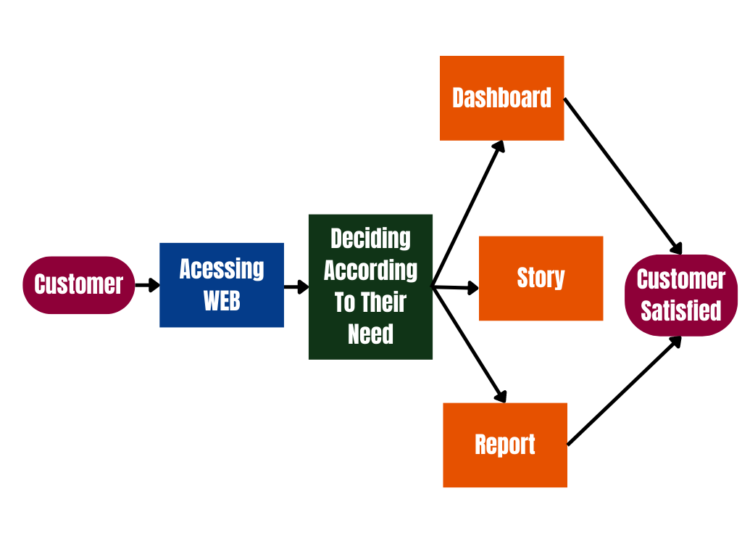

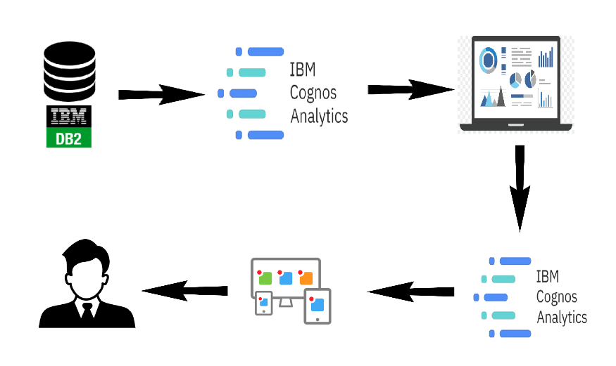

**4.2 Solution & Technical Architecture:**

The solution architecture for Data-Driven insights on Olympic Sports Participation and Performance involves several sub-processes that bridge the gap between business problems and technology solutions. The goals of the solution architecture are as follows:

* The best tech solution for Data-Driven insights on Olympic Sports Participation and Performance should be able to collect and integrate data from various sources, use advanced analytics and machine learning techniques, have a robust infrastructure, a user-friendly interface, robust security measures, be customizable, and scalable to meet the specific needs of different users. Describe the structure, characteristics, behavior, and other aspects of the software to project stakeholders.
* The features, development phases, and solution requirements for Data-Driven insights on Olympic Sports Participation and Performance include data collection and integration, advanced analytics and machine learning techniques, real-time data processing and analysis, customizable dashboard and user interface, predictive analytics, social media analysis, visualization tools, data security measures, planning and requirements gathering, data preprocessing and cleaning, data analysis and modeling, solution implementation and testing, deployment, and maintenance. The solution should also have a robust and scalable infrastructure, compatibility with various data sources and analytics tools, user-friendliness, customization options, secure data storage and transmission, and reliable and efficient performance.
* The specifications according to which the solution is defined, managed, and delivered for Data-Driven insights on Olympic Sports Participation and Performance include solution architecture, data sources, analytics tools, user interface, security, customization, testing, deployment, maintenance, and support. These specifications should be documented and communicated to all stakeholders involved in the solution development and delivery process.

Data Collection: Gather data from various sources such as official Olympic websites, sports federations, public datasets, and other reliable sources. This data includes information on athletes, countries, events, medals, rankings, and other relevant variables.

Data Analysis: Apply exploratory data analysis techniques to gain insights into Olympic sports participation and performance. This can involve statistical analysis, data visualization, and exploratory data mining to identify patterns, trends, and relationships within the data.

**4.3 User Stories:**

|  |  |  |  |  |  |
| --- | --- | --- | --- | --- | --- |
| **User Type** | **Functional Requirement (Epic)** | **User Story Number** | **User Story / Task** | **Acceptance criteria** | **Priority** |
| Customer (sports marketer) | Dashboard | USN-1 | As a user, I'm trying to identify the most promising Olympic sports and athletes to invest in. | I can access my dashboard | High |
| Customer (coach) | Dashboard | USN-2 | As a user, I'm trying to optimize my training programs to improve the performance of my athletes. | I can access my dashboard | High |
| Customer (sports journalist) | Report | USN-3 | As a user I'm trying to write engaging stories about Olympic sports and athletes. | I can access my Report,Story. | Low |
| Customer (Olympic athlete) | Dashboard | USN-4 | As a user, I'm trying to improve my performance in my sport. | I can access my dashboard | Medium |
| Customer (Fan) | Dashboard | USN-5 | As a user, I'm trying to gain a better understanding of the different sports and athletes competing in the games. | I can access my dashboard | Low |
| Customer (event organizer) | Report | USN-6 | As a user, I'm trying to create an engaging and successful Olympic sports event for spectators. | I can access my Report | Medium |
| Customer (sports data analyst) | Dashboard | USN-7 | As a user, I'm trying to develop accurate models for predicting the outcomes of Olympic sports events. | I can access my dashboard | Medium |
| Customer (sports sponsor) | Report | USN-8 | As a user, I'm trying to identify the most effective ways to promote my brand in connection with Olympic sports events. | I can access my report | High |
| Customer (Olympic sports broadcaster) | Dashboard | USN-9 | As a user, I'm trying to provide insightful and engaging commentary on live events. | I can access my dashboard | High |

**5. CODING & SOLUTIONING (Explain the features added in the project along with code)**

**5.1 Feature 1:**

Real-Time Data Updates: This feature allows the system to receive and process real-time data updates on Olympic sports participation and performance. It enables the system to continuously update and analyze the latest data, providing users with up-to-date insights and trends. This feature enhances the timeliness and accuracy of the information available, enabling stakeholders to make informed decisions based on the most recent data. It may involve integrating with live data sources, implementing real-time data processing and analysis algorithms, and displaying real-time updates on dashboards or reports.

**5.2 Feature 2:**

Predictive Analytics: This feature leverages historical data and statistical modeling techniques to generate predictions and forecasts related to Olympic sports participation and performance. By analyzing patterns and trends in past data, the system can provide insights on future outcomes, such as athlete performance, medal predictions, or trends in sports popularity. This feature can help stakeholders make informed decisions, optimize resource allocation, and anticipate potential challenges or opportunities. It may involve implementing machine learning algorithms, developing predictive models, and presenting forecasted results in visualizations or reports.

**5.3 Database Schema (if Applicable)**

**6. RESULTS**

**6.1 Performance Metrics:**

|  |  |  |
| --- | --- | --- |
| **S.No.** | **Parameter** | **Screenshot / Values** |
|  | Dashboard design | No of Visualizations / Graphs – 12 |
|  | Data Responsiveness |  |
| 3. | Utilization of Data Filters |  |
| 4. | Effective User Story | No of Scene Added – 3 |
| 5. | Descriptive Reports | No of Visulizations / Graphs – 3 |

**7. ADVANTAGES & DISADVANTAGES**

Advantages of performance metrics in a data-driven insights initiative for Olympic sports participation and performance:

* Improved Decision-Making: Performance metrics provide objective and quantifiable measures of the system's performance, enabling stakeholders to make informed decisions based on accurate and reliable data.
* Optimization of System Resources: By monitoring performance metrics, organizations can identify bottlenecks, optimize resource allocation, and ensure efficient utilization of computational resources, resulting in cost savings and improved system performance.
* Enhanced User Experience: Performance metrics help assess the responsiveness and usability of the system, allowing organizations to identify areas for improvement and provide a better user experience, resulting in increased user satisfaction and engagement.
* Scalability and Growth: Performance metrics provide insights into the system's scalability, enabling organizations to anticipate and accommodate increasing data volumes and user demands, supporting future growth and expansion.

Disadvantages and challenges of performance metrics in a data-driven insights initiative for Olympic sports participation and performance:

* Complex Measurement: Defining and measuring performance metrics accurately can be challenging, as different stakeholders may have different expectations and interpretations of what constitutes good performance. It requires careful consideration of relevant factors and metrics to ensure meaningful measurements.
* Subjectivity: Some aspects of system performance, such as user experience and satisfaction, can be subjective and challenging to quantify accurately. It may require the use of surveys, feedback mechanisms, or qualitative analysis to capture these aspects.
* Limited Scope: Performance metrics may focus primarily on technical aspects of the system, such as response time and resource utilization, while not capturing other important factors such as the impact on athletes or the broader social and economic implications of Olympic sports participation and performance.
* Data Collection and Integration: Obtaining accurate and comprehensive data for performance metrics can be a challenge. It requires collecting data from various sources, ensuring data quality and consistency, and integrating it into the performance monitoring system.
* Dynamic Nature: Performance metrics need to evolve and adapt to changing requirements, technologies, and user expectations. Regular review and refinement of performance metrics are necessary to ensure their continued relevance and effectiveness.

**8. CONCLUSION**

In conclusion, a data-driven insights initiative for Olympic sports participation and performance offers significant advantages for stakeholders involved in the sports industry. By harnessing the power of data analysis and visualization, such initiatives can provide valuable insights and inform decision-making processes.Through the use of performance metrics, organizations can monitor and optimize system performance, ensuring efficient data processing, analysis, and visualization. This leads to improved decision-making, optimized resource allocation, and enhanced user experiences. Additionally, the scalability and real-time data updates features enable the system to handle growing data volumes, adapt to changing requirements, and provide up-to-date information for stakeholders.

However, it is essential to address challenges such as defining relevant metrics, considering subjectivity, and ensuring data quality and integration. Regular evaluation and refinement of performance metrics are necessary to maintain their effectiveness and alignment with stakeholder needs.

Overall, a well-executed data-driven insights initiative with appropriate features and consideration of non-functional requirements can offer valuable insights, drive improvements in Olympic sports participation and performance, and support informed decision-making processes in the sports industry.

**9. FUTURE SCOPE**

The future scope of a data-driven insights initiative for Olympic sports participation and performance is promising, with several potential areas for growth and advancement. Here are some aspects that could shape the future of such initiatives:

* Advanced Analytics Techniques: As technology continues to evolve, there is room for incorporating more advanced analytics techniques into the data-driven insights initiative. This includes leveraging artificial intelligence, machine learning, and predictive modeling to uncover deeper insights, identify complex patterns, and make more accurate predictions about athlete performance, sports trends, and fan engagement.
* Integration of Emerging Data Sources: With the increasing availability of data from various sources such as wearables, social media, and video analytics, there is an opportunity to integrate and analyze these diverse data sets. This integration can provide a more comprehensive understanding of athlete performance, training methods, fan preferences, and overall sports participation dynamics.
* Personalized Insights: The future of data-driven insights could involve providing personalized insights and recommendations to athletes, coaches, and fans. By leveraging individual performance data, training regimens, and preferences, tailored recommendations can be generated to optimize training strategies, improve performance, and enhance fan experiences.
* Augmented and Virtual Reality: The incorporation of augmented reality (AR) and virtual reality (VR) technologies can revolutionize the way Olympic sports participation and performance data is visualized and experienced. AR/VR can provide immersive experiences, allowing users to virtually explore sports venues, visualize athlete performance metrics in real-time, and engage with interactive visualizations.
* Ethical and Responsible Data Usage: As data-driven insights initiatives continue to evolve, there will be an increased emphasis on ethical and responsible data usage. Organizations will need to prioritize data privacy, security, and transparency to ensure the protection of sensitive information and build trust with stakeholders.

**10. APPENDIX**

**Source Code:**

DASHBOARD:

<iframe src="https://us3.ca.analytics.ibm.com/bi/?perspective=dashboard&amp;pathRef=.my_folders%2FOlympic%2Bdashboard&amp;closeWindowOnLastView=true&amp;ui_appbar=false&amp;ui_navbar=false&amp;shareMode=embedded&amp;action=view&amp;mode=dashboard&amp;subView=model000001881488a247_00000000" width="1200" height="1000" frameborder="0" gesture="media" allow="encrypted-media" allowfullscreen="">

</iframe>

STORY:

<iframe src="https://us3.ca.analytics.ibm.com/bi/?perspective=story&amp;pathRef=.my_folders%2FOLYMPICS%2Bstory&amp;closeWindowOnLastView=true&amp;ui_appbar=false&amp;ui_navbar=false&amp;shareMode=embedded&amp;action=view&amp;sceneId=model0000018815591a48_00000002&amp;sceneTime=8500" width="1200" height="1000" frameborder="0" gesture="media" allow="encrypted-media" allowfullscreen="">

</iframe>

REPORT:

<iframe src="https://us3.ca.analytics.ibm.com/bi/?pathRef=.my_folders%2FOLYMPIC%2Breport&amp;closeWindowOnLastView=true&amp;ui_appbar=false&amp;ui_navbar=false&amp;shareMode=embedded" width="1200" height="1000" frameborder="0" gesture="media" allow="encrypted-media" allowfullscreen="">

</iframe>

APP.PY(FLASK):

from flask import Flask, render_template

app=Flask (__name__) # starting the Flask app

@app.route("/")

def index():

     return render_template("index.html")

if __name__== "__main__":

     app.run(debug = False)

**GitHub & Project Video Demo Link:**

GitHub Link: [naanmudhalvan-SI/PBL-NT-GP-18864-1683351649: Data-Driven insights on Olympic Sports Participation and Performance (github.com)](https://github.com/naanmudhalvan-SI/PBL-NT-GP-18864-1683351649)

Video Demo Link: <https://drive.google.com/file/d/18TyBky5q9t-3L0PNrJAmJ3294OwgmbR1/view?usp=sharing>